Alaska Indoor Gardening Curriculum

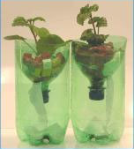
Passive Hydroponic System

Author/Source: Mel Sikes, Alaska Agriculture in the Classroom

Suggested Grade Levels: 3-8

Time: 45 minutes to 1 hour, monitoring time

Teaching Goal:
To introduce students to basics of how hydroponics works.

Learning Objectives:
To explore the hydroponic growing process by building and monitoring a soda bottle passive hydroponic system

Core Topics:
- Introduction to Hydroponic Systems
- Plant Dynamics (circulation and nutrient uptake)
- pH, Acidity, and Alkalinity Testing
- Recording Scientific Data in Tables
- Standardized Science Measurements
- Small Scale construction of a Hydroponic System
- Drawing Conclusions from Experimentation (hands-on, observation, and note-taking)

Alaska State Science Standards: 3-LS4-3, 4-LS1-1, 4-PS3-4, 5-PS3-1, 5-LS1-1, 5-LS2-1, MS-LS2-1, MS-LS2-4, MS-LS2-5, MS-ESS3-3, MS-ETS1-1

NGSS Standards: 3-LS1-1, 3-LS4-3, 4-LS1-1, 5-PS3-1, 5-LS1-1, 3-5-ETS1-1, MS-LS1-5, MS-LS2-1,
MS-LS3-3, MS-ESS3-3, MS-ETS1-1

Materials:
- 16 ounce water bottles or 2 liter soda bottles.
- Heavy-duty Scissors
- Rubber Bands
- Duct or Masking Tape
- Cotton wick material such as yarn, kite string, etc. about 16 inches per bottle. Handi Wipes cut into one-inch strips are excellent as well.
- Lettuce or Basil starts, plant cuttings, or seeds
- Hydroponic clay balls media, perlite or other porous grow medium. Rock wool or peat plugs if you are starting with seeds.
- hydroponic specific nutrients
- Water
- Grow Light
- Hand Drill or Power Drill.
- Wood block for drilling hole in cap

Vocabulary:
- Aerating: Adding air to the growing media.

- Anchorage: Plant roots and stems becoming stabilized or “anchored” in their growing media. In hydroponics systems, devices or systems must anchor plants in the absence of soil.

- Capillary Action: The ability of a liquid to flow in narrow spaces without the assistance of, or even in opposition to, external forces like gravity.

- Hydroponics: The art and science of crop production in liquid media.

- Nutrient: The mineral quantities plants need to obtain optimum growth.
- Nutrient solution: The replacement of soil in a hydroponic solution that supplies the plant with nutrients, water, air, and anchorage.

- Passive Hydroponics: Growing plants hydroponically without soil and electric water pumps

- Primary nutrients: The mineral nutrients plants need in the greatest quantities: Nitrogen (N), Phosphorus (P), and Potassium (K).

- Respiration: The process by which the plant sugars produced in photosynthesis are used up (or burned) to produce energy for the plant’s life processes.

- Transpiration: Evaporation or loss of water through plant surfaces.

Background for Teachers:
Passive hydroponics, semi-hydroponics or passive sub-irrigation is a method of growing plants without soil, peat moss, or bark. Instead, an inert porous medium transports water and fertilizer to the roots by capillary action. Water and fertilizer are held in a reservoir and conducted to the roots as necessary, reducing labor and providing a constant supply of water to the roots. In the simplest method, the pot sits in a shallow solution of fertilizer and water or on a capillary mat saturated with nutrient solution. Since routine maintenance is much simplified, passive hydroponics can reduce the labor required to maintain a large collection of plants.
The various hydroponic media available contain more air space than more traditional potting mixes, delivering increased oxygen to the roots. Allowing air to reach the roots is particularly important in preventing root rot in epiphytic plants such as orchids and bromeliads, whose roots are exposed to the air in nature. Passive hydroponics also may add additional ambient humidity through evaporation. It is important in passive sub-irrigation to wash out the system from time to time to remove salt accumulation. Plants that require drying between watering or a dry dormant period may fail to thrive under the constant moisture of passive hydroponics. – Wikipedia

Procedure:
1) Discuss the basic needs of plants. Nutrients, Light, Water, Air. Teach or review “What is the LAW for plants?” L.A.W. (light, air, water- best for younger students) and/or PL.A.N.T.S. (place, light, air, nutrients, thirsty, soil-best for older students).
2) Discuss what hydroponic means and why soil isn’t necessary for growth.
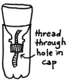
2) Pass out the bottles to the students. Drill holes that are slightly smaller than the diameter of the wicking material into the bottle caps. Return to the top of the bottles. This can be done with a hand drill or ahead of time by the teacher.
3) Cut the wicking material to 16”. Thread the wicking material through the hole so that half of the wick is on each side of the cap.
4) Cut the bottle a little below the spot where the top of the bottle stops curving using scissors. You can cover the cut edges on the outside with duct or masking tape. That will also help keep the top from slipping down into the bottle. Leave the cap on the top.
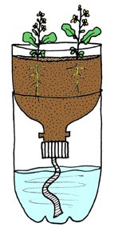
5) Mix nutrient solution and water in bottle. Read directions for correct % of nutrient to water.
6) Invert the bottle top and fill with clay balls (weaving the wick material through the media.) Make sure the wick material is hanging into the solution.
7) Place plants or seeds in small portions of rockwool in the media.
8) Place bottles in a sunny window or under a grow light.

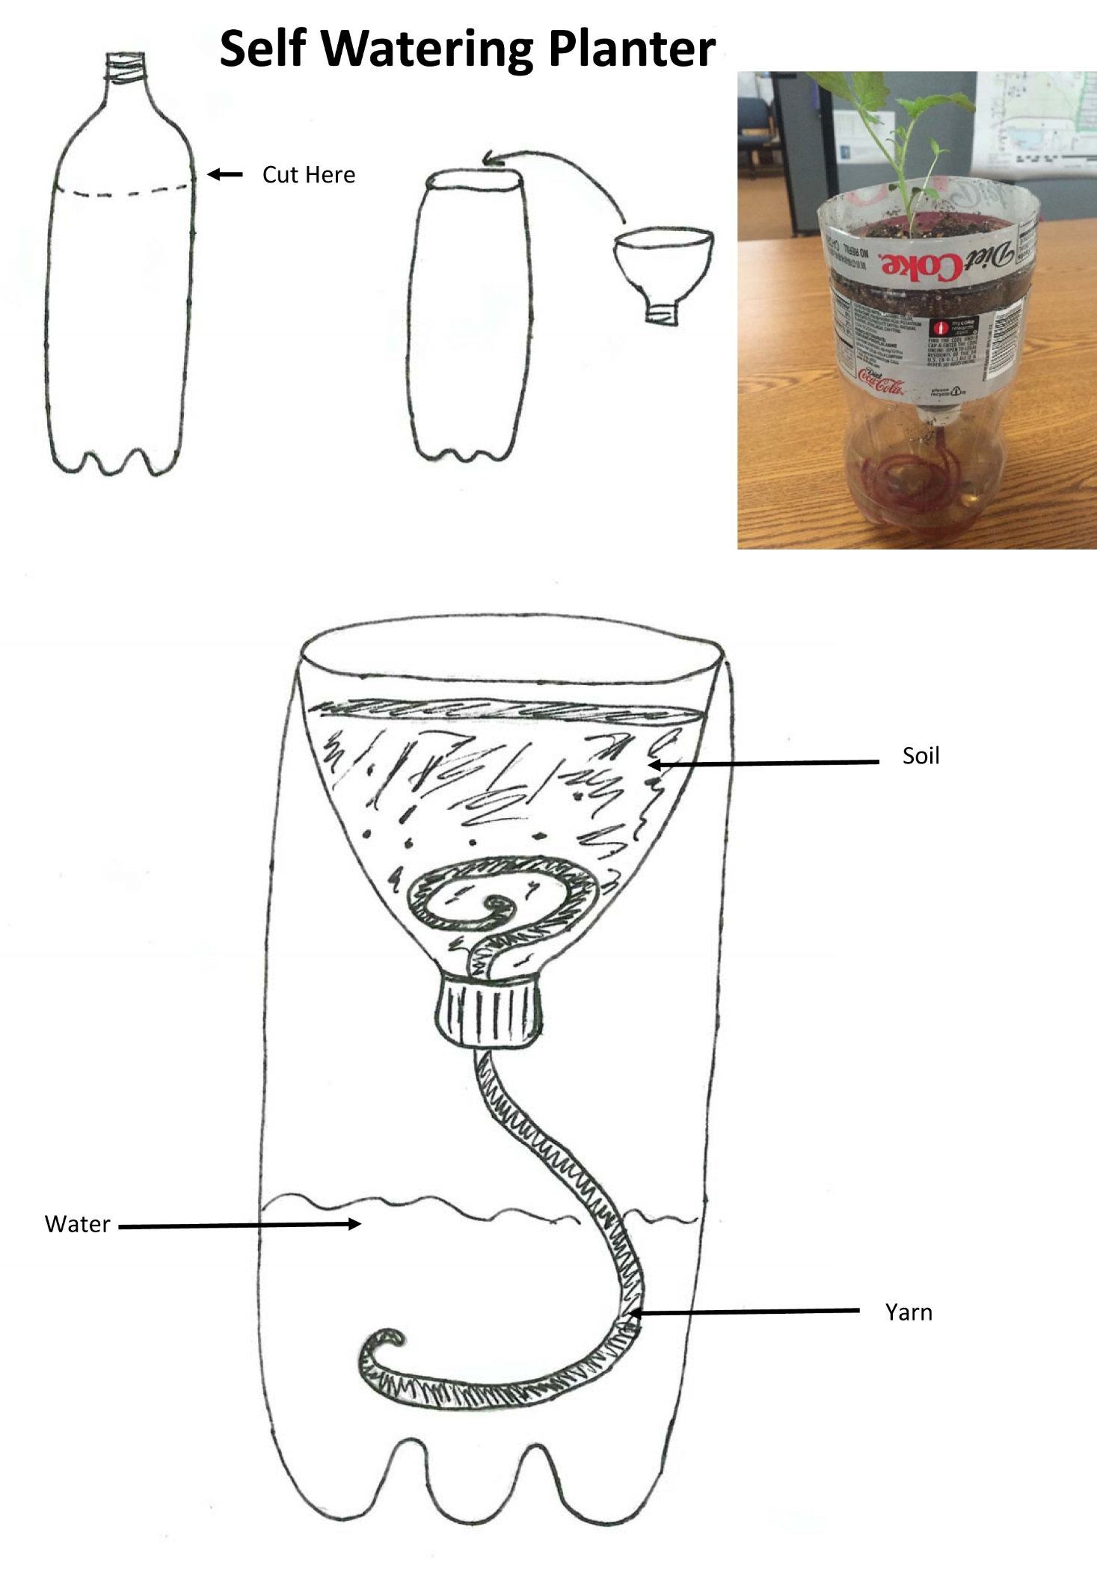
8) Monitor plant growth and refill water solution as necessary.
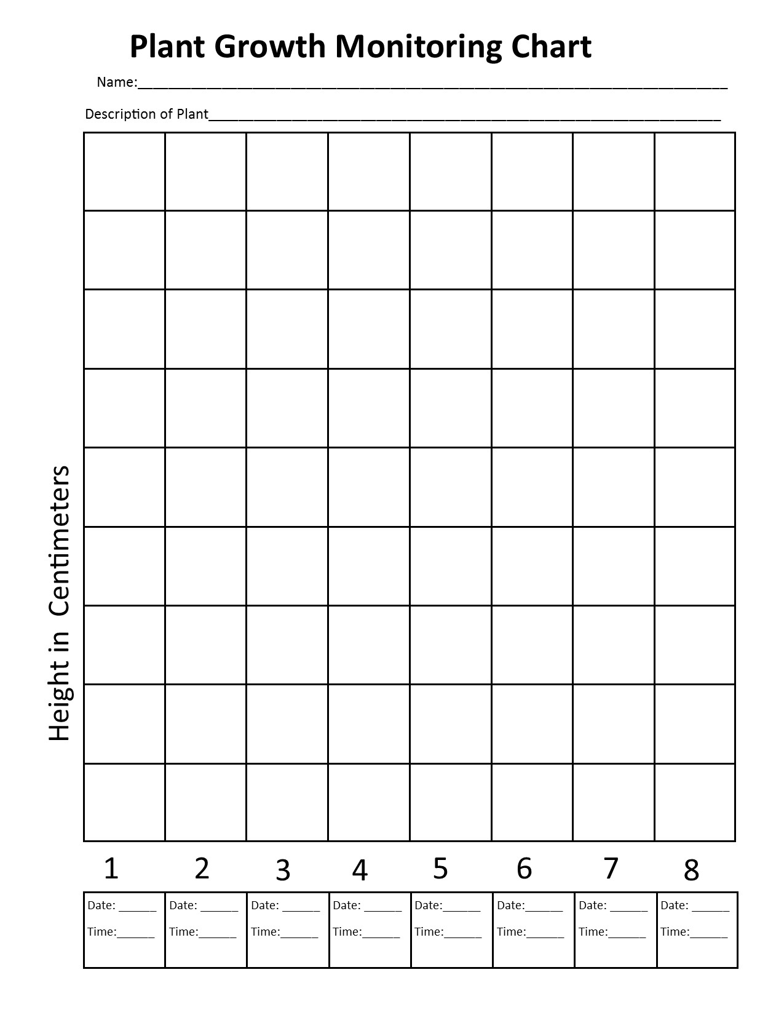
ensions: Plant Processes Lesson, Seed Science Lesson, Intro to Hydroponics Lesson

Assessment: Growth Monitoring Chart, successful plant growth. Student can explain system to others.

References:
Books:
Bottle Biology by Wisconson Fast Plants Program
ISBN: 978-0757500947

Gardening Indoors with Soil and Hydroponics
by George Van Patten 2007 ISBN: 978-1-878823-32-8

How to Hydroponics by Kenneth Roberto
ISBN: 0-9672026-1-2 2014

Hydroponic Basics: The Basics of Soilless Gardening Indoors
by George F. Van Patton 2004 ISBN: 978-1-878823-25-0

Hydroponics: A Complete DIY Guide for Gardening Using Simple Steps
by Allen Dunn 2012 ISBN: 9781480236141

Websites:
Bottle Biology: http://www.bottlebiology.org/index.html

Foothill Hydroponics: http://www.foothillhydroponics.com/

General Hydroponics: http://generalhydroponics.com/

Hydroponics: https://hydroponics.com/

Institute of Simplified Hydroponics: http://carbon.org/

Simply Hydroponics and Organics: http://www.simplyhydro.com/system.htm

Uponics: http://uponics.com/hydroponic-tower/

